

American International University-Bangladesh (AIUB)  
**Department of Computer Science  
Faculty of Science &Technology (FST)  
Fall 19_20**

**E-Stationary**

A software Engineering Sec: **D** project submitted

By

*Fahad Mollah (18-36702-1)*

The project will be Evaluated for the following Course Outcomes

|  |  |
| --- | --- |
| CO3: Choose appropriate software engineering model in a software development environment | Total Marks |
|  |
| Content Knowledge [5Marks] |  |
| Argumentation [5Marks] |  |
| Evidence of Argumentation [5Marks] |  |
| Completeness, Spelling, grammar and Organization of the Answer [5Marks] |  |
|  | |
| CO4: Explain the roles and their responsibilities in the software project management activities | Total Marks |
|  |
| Project Background Analysis [5Marks] |  |
| Project Role identification [5Marks] |  |
| Responsibility Description [5Marks] |  |
| Completeness, Spelling, grammar and Organization of the Answer [5Marks] |  |

Corporate Personnel Name: Md. Samsuzzoha

Company: SELISE rockin software

Designation: Software Engineer

Contact Details: [mzs@sekise.ch](mailto:mzs@sekise.ch)

Sign: 

Table of Content:

|  |  |
| --- | --- |
| SL. | Content |
| 1. | Scenario |
| 2. | Features |
| 3. | Project details with functionality |
| 4. | UML with Description |
| 5. | Estimation |
| 6. | Role |
| 7. | Process Model |
| 8. | Scheduling |
| 9. | Risk |
| 10. | Reference |

## **E-Stationary**

Stationary App is a desktop application where the user use the app for online stationary purchases. There are many features to show the users that they can choose their require-able products. There is an admin to manage the process. Admin have to login with his/her own pin code. Admin display their inventories in the homepage. Every users can show the inventories. If user wants to buy any product then user have to login with their pin code and if the user is new then she/he have to sign up for purchase any product. After receiving the products they have to pay on cash. Users can return their product with valid reason within a specific time. Users can share both positive and negative reviews on their purchases products. Admin can add or remove products after getting reviews. There are some offers for regular users on purchasing

**Features**

1. **Admin**

* Login: Admin will login to his own account using admin ID and password
* Store Inventory: Added Product with product Details and Remove a product
* Offers: There will be up-to 10% offers for regular customers on specific products.
* Summary: Records for all selling products or return products and any transaction

1. **User**

* Selection: Customer can search for any product or they can select a product from homepage.
* Login or Signup: User can order the product using their account.
* Payment: Customer will pay by Cash on delivery.
* Review: After order received customer have a review option. They can give a review for the product
* Return: User can send a request for return the product.

**Advantage:**

1. It is an Online based software, so it is simple and easier than actual shopping.
2. It saves time
3. Have return policy.

**Disadvantage:**

1. User must have login or create an account to purchase a product.

**Application:** The system can be-used in all online-based electronic devices.

**Does the project have a clear target market or audience?**

Yes, our project has a clear target market for stationary management system where user can easily purchase their product in a secured way from their home. They don’t need to go outside for purchase any stationary product. Therefore, it’s time-consuming app for any user. User can research firsthand experience, ratings, and reviews for all products. By using this app user can get exactly what they want and need. Cheap deals and better prices are available in this system, because products come to the user direct from the seller without involving intermediaries.

**Does the team demonstrate a thorough understanding of the need, problem or opportunity, including evidence of research into the need, problem or opportunity?**

We demonstrate that our app has become a big issue for the security because we process all things in a secured way. Here, regular user will get various kind of offers and users can-also return their purchases product with valid reason.

**Is the project’s purpose and basic functionality easily understood?**

Yes, the purpose and basic functionality are easily understand to the general people. There are a lot’s of people who does not want to go outside for shopping so this app is useful for them. As online shopping system are well known to our country so people will not feel hesitate to use it.

1. **CLASS DIAGRAM**

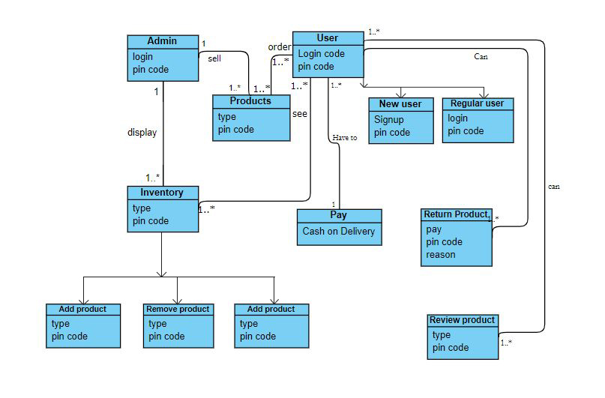

The class diagram includes the major classes. Class admin have attributes login, pin-code, identification. Class user have attributes login, pin code identification. However, new user have signup attributes. Inventory is a class with types and code attributes. It has three sub classes as add product, remove product and offered product. There is a product class also. Pay is a class that has one attribute is cash on delivery. Reviews product is also a class with type, code and reason.

1. **ACTIVITY DIAGRAM:**

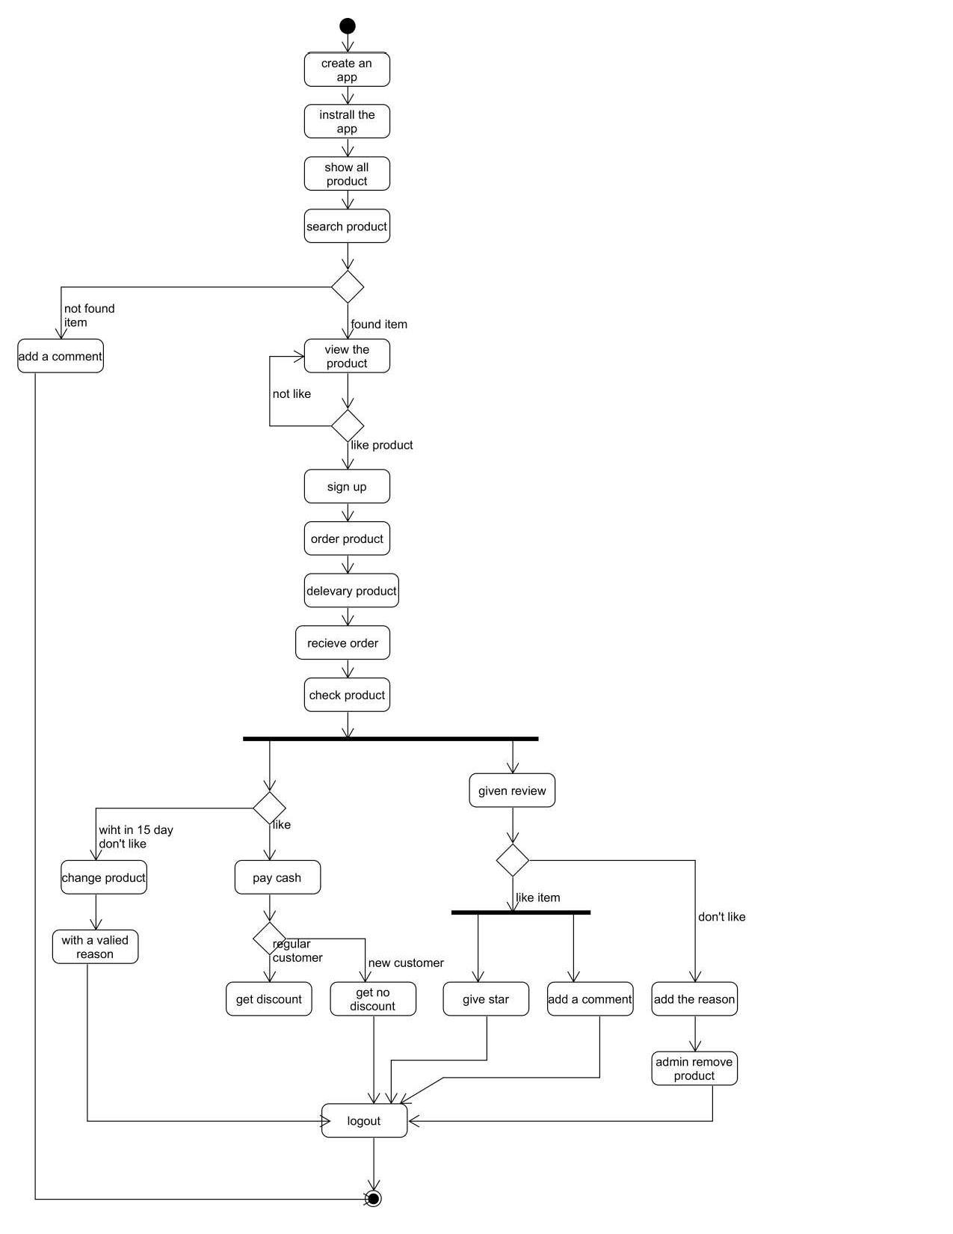

The activity diagram includes the major activities. The activity of stationary app allow the users to find their desire products. After use the sign-up activity user can order their products and can receive products by cash. After using this app users could give their reviews and can take the advantage of return policy with valid reason.

1. **Use Case Diagram**

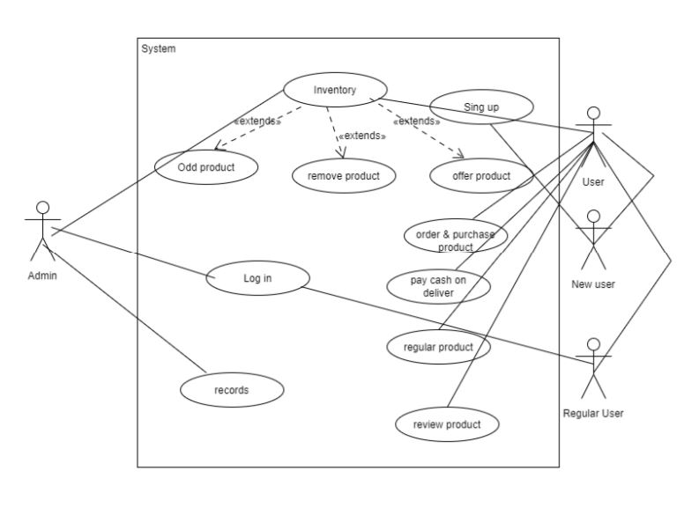

The use case diagram includes the major use cases. ‘Login is a use case by which both admin and user can log into their accounts. New user have to sign-up with the signup use case. Inventory is a use case where products can be add, remove and offer for users. By using ‘inventory’ use both admin and user can display and see the products. “Purchase and order product’ is also a use case by which user can order products. ‘Pay cash on delivery’ is another use case to pay by users. Users can return their purchases products by using ‘return product’. User can also review the product by using ‘review product use case. ‘Record is a use case for admin to look up the summary.

**Estimation**

Scope

Schedule

Budget

9-

COST PLAN

10-

PAYMENT PLAN

8-

PLAN

7-

RECOURCES

6-

GANTT CHART

5-

NETWORK DIAGRAM

4-

MILESTONE

3-

ESTIMATE

2-

WBS

1-

PBS

Effort= PM= Coefficient<Effort Factor> *(SLOC)^P

[As Coefficient= 2.4, Sloc= 5000/1000=5 SLOC, P=1.5]

So, PM= 2.4*(5)^1.05

=14 person-month

Development time=DM=2.50*(PM)^T

DM= 2.50*(14)^0.38 [As PM= 14,T=0.38]

= 7 month

**Role:**

|  |  |
| --- | --- |
| **Name** | **Activity** |
| Turny, Tania Tasnim | Topic, Features, Advantage, Disadvantage, Activity Diagram |
| Ashreen Sumaiya | Scenario, Use case diagram, Class Diagram |
| Hoque Fahmida | Model Analysis, Estimation, Risk, Reference |
| Mollah Fahad | Scheduling, Problem analysis, Company Related task |

**Process Model**

* According the project information, we are going to follow agile model in order to develop the software.

Agile is a process that helps team by provide quick and unpredictable responses to the feedback they receive on their projects. It creates opportunities to assess a project’s direction during the development cycle. Team assess the project in regular meetings called sprint or iteration.

An agile is a very empower process that helps companies design and build the right project The management process is very beneficial for software analyze and improve their product throughout its development. This enables companies to produce highly valuable products so they stay competitive in the market. Agility is the ability to create and respond to change in order to profit in a turbulent business environment. Therefore, our project easily connected with agile method and fulfilled all our requirements.

* **Sufficient arguments in support of our model**

For software implementation, any companies need to innovate better and faster operations, new technology and how to fulfill customer requirements. As we know agile method is a lightweight and people based, so using agile we could easily satisfy the customer. Changing requirements even late in development, agile process control change for the customer’s competitive advantage. Deliver frequently working software with a preference to the shorter timescale (at least 30 days). Business people and developers must work together daily throughout the project. In this process, the developer team and the customer easily can connect with each other. Actually agile method gives support.

**Scheduling:**

Project scheduling is an activity in which we decide how we will divide the project into the smaller task. We also decide how these tasks will be execute and how much time a task will take to complete.

For our project, following two steps are very important.

1. Set Milestone: Our 1st milestone will be consist on first two tasks if our project is divided into many tasks.
2. Estimate resources: If our project is divided into 6 tasks let suppose so we should have knowledge what kind of and how much resources are required to complete specific task.

**Schedule Representation:**

Let we divided our projects into 7 tasks.

|  |  |  |
| --- | --- | --- |
| **Task** | **Duration** | **Dependencies** |
| T1 | 14 |  |
| T2 | 7 | T1 |
| T3 | 20 | (M1) |
| T4 | 6 | T3 |
| T5 | 27 | (M2) |
| T6 | 7 |  |
| T7 | 10 | (M3) |

Here, Task= T; Milestone= M

**ACTIVITY BAR CHART:** (WEEKLY BASIS)

|  |  |  |  |  |  |  |
| --- | --- | --- | --- | --- | --- | --- |
| Week | 1 | 2 | 3 | 4 | 5 | 6 |
| T1 |  | |  |  |  |  |
| T2 |  |  | T1 |  |  |  |
| T3 | T2(M1) | | |  |  |  |
| T4 |  |  |  | T3 |  |  |
| T5 |  |  | (M2) | | | |
| T6 |  |  |  |  |  |  |
| T7 |  |  |  |  | (M3) | |

**Risk:**

In our app, there are activity that uses a variety of technological advancements and requires high level of knowledge. Because of these and others factors every software projects contains elements of uncertainly. This is known as project risk. As project manager, it’s not enough to merely be aware of the risk. To achieve a successful outcome, project leadership must identify assess, prioritize and manage all of the major risks. Risk is a potential problem. Risk management includes the following tasks…

* Identify Risks and triggers.
* Classify and prioritize all risks.
* Construct a plan that links each risks to a mitigation.
* Monitor for risk triggers during the project.
* Implement the mitigating action if any risks materializer.

Risk management is an extensive discipline and we have only given an overview here.

**Reference:**

* Pfleager. S.L (1998) Software Engineering: Theory and Practice, Prentice Hale.
* R.S Pressman & Associates, Inc (2010) Software Engineering : A Practioner’s approach.
* Center for Software Engineering. USC (1998) COCOMO || model Definition Manual.